Curriculum Vitae
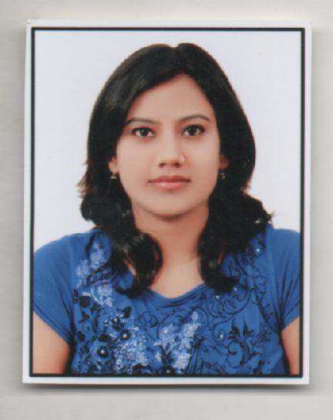
Name: KANUPRIYA
Contact number: +919953669293
E-mail address: kanupriya319@gmail.com

Career Objective:
To seek challenging assignment and responsibility with an opportunity for growth and career advancement as a successfully achievement.
Strengths:
• Sincere, hard working and ability to adapt to new environments and grasp new
concepts
• Readiness to shred legacy systems and work towards newer ideas
• Ability to respond to demanding situations with a rational, analytical approach
• Effective in performing under pressure & keep people motivated
• Confident with strong communication and presentation skills

Education:
Qualification
School | Board | Aggregate percentage | Year
Bachelor of pharmacy | H.R.Institute Of Pharmacy,Ghaziabad(HRGI) | UPTU | 61 | 2014
12th | Sree Ayyappa Public School | CBSE | 61 | 2008
10th | D.A.V. Public School | CBSE | 76 | 2006

Subjects of interest:
- Pharmacology

Key Skills:
Summary
- Professional Knowledge with increasing responsibilities and successful record of achievements in application design and statistical analysis.
- Knowledge on working with SAS under platforms such as Windows 2000, XP.
- Knowledge in Base SAS, SAS SQL.
- Knowledge in analysis of data for statistical analysis and reporting.
- Knowledge in producing external files and reports employing various SAS procedures, like Proc Import, Proc Export, Proc Append, Proc Print, Proc Freq, Proc Tabulate, Proc Means, Proc Transpose.
- Knowledge on working with Excel, PowerPoint and ODS HTML formatted files to produce adhoc reports to the Users and Business Partners for Presentation and further Analysis
- Export / extract data from databases and perform migration of data using Upload, Download.
- Strong exposure in Business and Data analysis, design and training of users. Ability to work independently / in a team environment and ability to absorb technical knowledge quickly.
- Ability to handle Statistical Reports.
Specialization SAS , SQL., Base SAS
Projects :
- Report on Astron Pharmaceutical company(Meerut) .
- Report on market behavior on various antipyretic drugs.
Achievements/ Extracurricular activities:
- Core member of various technical and cultural event
- Participated and cordinated various events in NECTAR and TECHVAGAZA the Annual cultural and technical fest.
- Winner of fashion event.
- Active participent in National Seeminars held yearly.

Hobbies:
- Reading.
- Dancing.

Personal Details:

Date of birth: 16th March 1991
Mother’s name: Mrs. Poonam Singh
Father’s name: Mr. Sunil Kumar Singh
Permanent address: W.No.-1,Nawada Bishunpur Road (near DVC chowk),
Jhumari Tilaiya(JHARKHAND)
Current address: B-27,2nd floor,Dayanand colony
Lajpat nagar 4
New Delhi 110024

Date: 15/12/2014
(Kanupriya)

